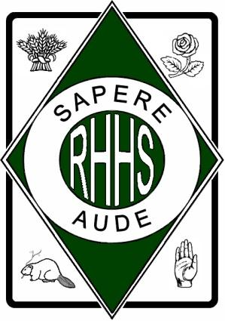
R I C H M O N D H I L L H I G H S C H O O L

201 Yorkland Street
Richmond Hill, ON L4S 1A2
Telephone: 905 884 2131
Fax: 905 884 9653
Email: richmond.hill.hs@yrdsb.ca
Website: http://www.yrdsb.ca/schools/richmondhill.hs
Dear Parent/Guardian:

The DECA advisors, staff and administration of Richmond Hill High School would like to take this opportunity to congratulate your son/daughter on their accomplishments at DECA this year. We are so pleased that they will be going on to represent our school at this year’s DECA International event.

We wish them continued success and the best of opportunities and experiences at DECA’s ICDC event in Atlanta, Georgia, April 20th 2018 to April 26th 2018.

As part of their requirement to participate at ICDC, there is a mandatory information meeting that must be attended by the students, with a parent component to the meeting. Parents are invited to attend this meeting to have all of the information and expectations about this trip presented to them.This meeting will be held on:

Saturday April 7th 2018 at The Toronto Sheraton Centre, 123 Queen Street West, Toronto ON M6H 3M9, Osgoode Ballroom 9:30-3:00 p.m. All students must show photo ID and must sign in at the Osgoode Ballroom. Parent meeting will be scheduled from 2:00 – 3:00 pm.

THERE WILL BE A MANDATORY YRDSB PARENT AND STUDENT MEETING IMMEDIATELY FOLLOWING THE DECA MEETING BEGINNING AT 3:00 PM

All students must be in attendance or their subsidy may be revoked.

Further details and a finalized schedule for the day will follow shortly and will also be available on the DECA website.

Please acknowledge your participation in this meeting/training day by signing this form and returning it to Ms. Axelrod.

Ms. Axelrod
DECA Advisor

______________________________________________________________________________
Student Name Student Signature Date

______________________________________________________________________________Parent Name Parent Signature Date

