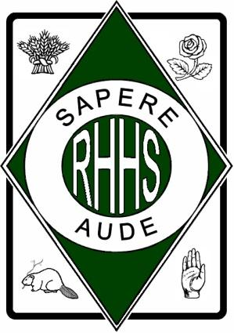
R I C H M O N D H I L L H I G H S C H O O L

201 Yorkland Street
Richmond Hill, ON L4S 1A2
Telephone: 905 884 2131
Fax: 905 884 9653
Email: richmond.hill.hs@yrdsb.ca
Website: http://www.yrdsb.ca/schools/richmondhill.hs

Student Expectations Contract
DECA ICDC April 20-April 26, 2018

Your son/daughter, _________________________, has chosen to represent RHHS and the York Region District School Board on a study tour to Atlanta, Georgia April 20, 2018 to April 26, 2018 inclusive.

In representing a school, it is important to note that at all times during this trip, students need to adhere to school rules, regulations and the behaviour code in order to leave a lasting impression with our hosts that solidifies our great reputation. The students that are going on this trip are involved because of our belief in them to show good character. This includes attributes such as honesty, integrity, respect, responsibility and fairness.

Despite our belief in the students, it is important to remind parents/guardians and students of the following expectations on extended study tours:

- Always be on time for events. Tardiness causes the entire group to be delayed.
- Follow curfew times. Be where you are supposed to be at all times.
- Do not consume any alcoholic beverages or be under the influence of any illegal drug at any time during the trip.
- Never allow “other people” (besides your classmates) into your hotel room.
- Be respectful of other people who may be in our hotel. Keep noise levels low at all times.
- Follow appropriate by-laws with respect to smoking cigarettes.
- Always behave appropriately representing RHHS in a positive and excellent manner.

It is our hope that none of these expectations are breached by any of the students. If, however, there is a situation that arises that is deemed to be inappropriate, the adult chaperones will determine the best course of action for the student and his/her family. Serious offences may result in parent contact and possibly the need to return the student to Ontario at the expense of the parents/guardians. They may also involve further disciplinary action such as suspension by the school.

We are looking forward to an amazing, memorable experience for all involved.

I have read and understand the expectations outlined above. I understand that <RHHS teachers> will be taking my son/daughter out of Ontario to Atlanta, Georgia from April 20, 2018 to April 26, 2018.

_________________________________________________________________
(Student) (Date) _________________________________________________________________ (Parent/Guardian) (Date)

